**Parent Instructions for Accessing 1st Quarter Student Report Cards**

Parents are able to view their child’s report card through an app called Virtual Counselor. This app can be found in your child’s Clever SSO page.

**From your child’s Clever account, click on “Virtual Counselor”.**

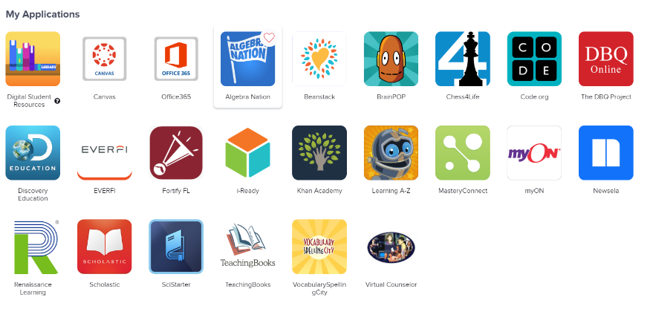

Click Here

**Students in Grades K-2:** Your child’s report card can be accessed as a pdf file by clicking the link “2021 Elementary School Report Card – Marking Period 1”

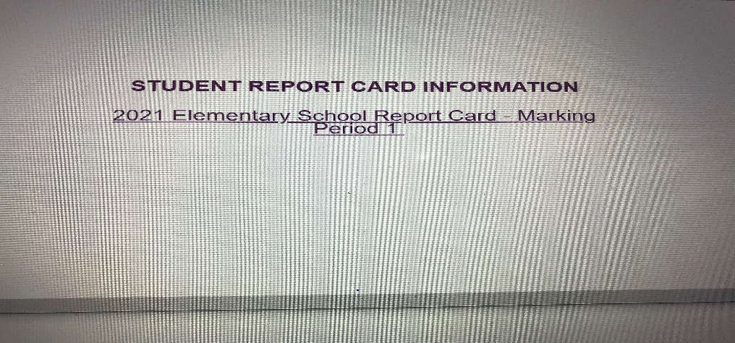

Click Here

**Students in Grades 3-5:** Your child’s report card grades for 3rd quarter will be displayed on the screen.